|  |  |
| --- | --- |
| *Pacific Gas and Electric Company* | |
| Release 8.5 Installation Guide | |
|  |  |
|  |  |
| Project | ED AM/GIS |
|  |  |
| Prepared by | Ashish Narasimham |
| Date | 7/14/2014 |
| Version | 1.1 |
| Version Type | Final |

|  |  |  |  |
| --- | --- | --- | --- |
| Revision History | | | |
| Document # | Date | Author | Summary of Changes |
| 1.0 | 6/30/14 | Ashish Narasimham | Initial Document Creation |
| 1.1 | 7/9/14 | Roger Carribine | Added support for DCConductor in UFM; Added updates based on UFM configuration audit. |

# Introduction

## Purpose

This document is intended to detail the implementation and configuration steps required to implement Release 8.5 Installation Guide. This document describes the various configuration aspects required to complete any manual or automatic patch associated with this release. Each section in this document contains the steps required to patch the system in production.

## Terms Used

|  |  |
| --- | --- |
| OOTB | Out of the box. Unmodified from the commercial version. |
| TFS | Team Foundation Server |

## External Documents

Referenced are any external configuration documents or exports. These are documents that contain more detailed information about configuring a system or documents that can be loaded into an application to perform the configuration detailed in this document.

## List Of Fixes

Below is the list of change requests detailing all fixes for the data model for this release:

|  |  |  |  |
| --- | --- | --- | --- |
| **Item Number** | | **Title** | **Work Item Type** |
| [15818](http://edappgistfsprd1:8080/tfs/web/wi.aspx?pcguid=15e9a9d1-95cb-4dd0-abfe-5af14ae6201f&id=15818) | | Data Model Changes for UFM v8.5 | Change Request |
| [15844](http://edappgistfsprd1:8080/tfs/web/wi.aspx?pcguid=15e9a9d1-95cb-4dd0-abfe-5af14ae6201f&id=15844) | UFM unique facility ID requirement | Change Request |
| [15845](http://edappgistfsprd1:8080/tfs/web/wi.aspx?pcguid=15e9a9d1-95cb-4dd0-abfe-5af14ae6201f&id=15845) | Conductor cross section anno | Change Request |
| [15846](http://edappgistfsprd1:8080/tfs/web/wi.aspx?pcguid=15e9a9d1-95cb-4dd0-abfe-5af14ae6201f&id=15846) | Dupe attributes that drive symbology for data entry | Change Request |
| [15847](http://edappgistfsprd1:8080/tfs/web/wi.aspx?pcguid=15e9a9d1-95cb-4dd0-abfe-5af14ae6201f&id=15847) | Create new fields in DuctDefinition object class | Change Request |
| [15848](http://edappgistfsprd1:8080/tfs/web/wi.aspx?pcguid=15e9a9d1-95cb-4dd0-abfe-5af14ae6201f&id=15848) | Create new fields in DuctBank feature class | Change Request |
| [15849](http://edappgistfsprd1:8080/tfs/web/wi.aspx?pcguid=15e9a9d1-95cb-4dd0-abfe-5af14ae6201f&id=15849) | Create new fields in SubsurfaceStructure feature class | Change Request |
| [15850](http://edappgistfsprd1:8080/tfs/web/wi.aspx?pcguid=15e9a9d1-95cb-4dd0-abfe-5af14ae6201f&id=15850) | Create new fields in Duct feature class | Change Request |
| [15851](http://edappgistfsprd1:8080/tfs/web/wi.aspx?pcguid=15e9a9d1-95cb-4dd0-abfe-5af14ae6201f&id=15851) | Add LabelText 2 field to SecUGConductor | Change Request |
| [16092](http://edappgistfsprd1:8080/tfs/web/wi.aspx?pcguid=15e9a9d1-95cb-4dd0-abfe-5af14ae6201f&id=16092) | Add Labeltext 2 field to DCConductor | Change Request |
| [16093](http://edappgistfsprd1:8080/tfs/web/wi.aspx?pcguid=15e9a9d1-95cb-4dd0-abfe-5af14ae6201f&id=16093) | DCConductor Labelling | Change Request |
| [16094](http://edappgistfsprd1:8080/tfs/web/wi.aspx?pcguid=15e9a9d1-95cb-4dd0-abfe-5af14ae6201f&id=16094) | Create Missing Relationship Between DCConductor and Duct | Change Request |
| [16095](http://edappgistfsprd1:8080/tfs/web/wi.aspx?pcguid=15e9a9d1-95cb-4dd0-abfe-5af14ae6201f&id=16095) | Apply Missing UFM Autoupdaters | Change Request |
| [16096](http://edappgistfsprd1:8080/tfs/web/wi.aspx?pcguid=15e9a9d1-95cb-4dd0-abfe-5af14ae6201f&id=16096) | Add Butterfly Cross Section feature class | Change Request |
| [16097](http://edappgistfsprd1:8080/tfs/web/wi.aspx?pcguid=15e9a9d1-95cb-4dd0-abfe-5af14ae6201f&id=16097) | Modify PGE_CIRCUITCOLOR table | Change Request |
| [16098](http://edappgistfsprd1:8080/tfs/web/wi.aspx?pcguid=15e9a9d1-95cb-4dd0-abfe-5af14ae6201f&id=16098) | Add Conversion fields to CrossSection50 Anno | Change Request |
| [16188](http://edappgistfsprd1:8080/tfs/ElectricDistCollection/EDAMGIS/_workitems#_a=edit&id=16188) | Add annotation feature class for VaultPoly | Change Request |
| [16195](http://edappgistfsprd1:8080/tfs/ElectricDistCollection/EDAMGIS/_workItems#_a=edit&id=16195&triage=true) | Update Duct Annotation placement rules | Change Request |
| [16197](http://edappgistfsprd1:8080/tfs/ElectricDistCollection/EDAMGIS/_workItems#_a=edit&id=16197&triage=true) | Update Map Multiplier | Change Request |
|  |  |  |
|  |  |  |
|  |  |  |
|  |  |  |
|  |  |  |
|  |  |  |
|  |  |  |
|  |  |  |

Contents

1 Introduction 3

1.1 Purpose 3

1.2 Terms Used 3

1.3 External Documents 3

1.4 List Of Fixes 4

2 Open a Database Connection in ArcCatalog 7

3 UFM unique facility ID requirement 8

4 Conductor Cross Section Anno 10

5 Dupe attributes that drive symbology for data entry 19

6 Create new fields in DuctDefinition object class 21

7 Create new fields in DuctBank feature class 26

8 Create new fields in SubsurfaceStructure feature class 27

9 Create new fields in Duct feature class 28

10 Add LabelText 2 field to SecUGConductor 29

11 Add LabelText 2 field to DCConductor 32

12 DCConductor Labelling 35

13 Modify PGE_CIRCUITCOLOR table 38

14 Create Missing Relationship Between DCConductor and Duct 40

15 Apply Missing UFM Autoupdaters 46

16 Add Butterfly Cross Section feature class 49

17 Add Conversion Fields to the 1:50 Cross Section Anno 56

18 Add Annotation Feature Class for VaultPoly 57

19 Apply Permissions to new Classes 60

20 Apply UFM Annotation Model Names 61

21 Update Duct Annotation 63

22 Update Map Mulitplier 64

23 Update Data Model Version Table 65

24 Known Issues 66

# Open a Database Connection in ArcCatalog

1. Open ArcCatalog.
2. Within the Catalog Tree, expand “Database Connections” and open the active connection for this process. This is the connection that is referenced in the change request associated with this document (EDGIS<DB name in the format X#Y> )

# UFM unique facility ID requirement

1. In the ElectricDataset, right click SubsurfaceStructure and select ArcFM Properties Manager.
2. In the Field Model Names tab, select STRUCTURENUMBER and double click FACILITYID from the 'Selected' box to unassign the model name from the field.  
   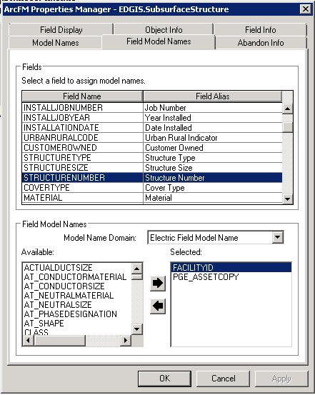
3. Select GLOBALID.
4. In the 'Available' box, double click FACILITYID to assign it as a field model name. If the model name is not visible in the box, ensure 'Electric Field Model Name' is selected for the model name domain.  
   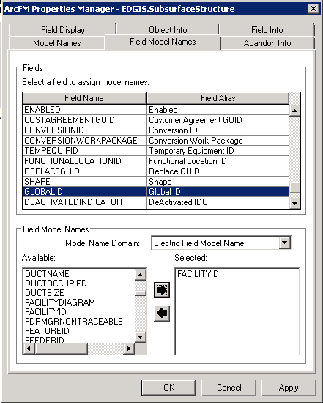

# Conductor Cross Section Anno

1. In the ElectricDataset, double click PriUGConductor.
2. Scroll to the bottom.
3. Add a LABELTEXT3 field to the PriUGConductor feature class:

Alias: Label Text 3  
Data Type: Text  
Allow Null: Yes  
Length: 100

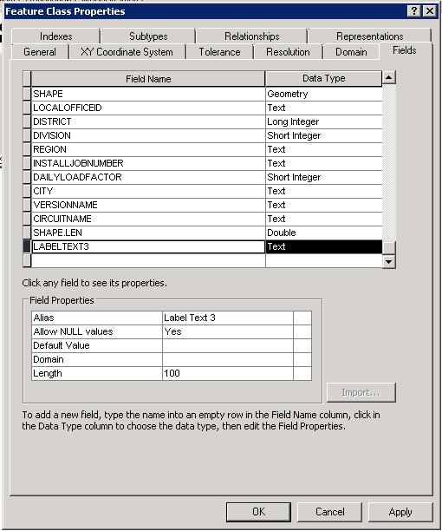

1. Click OK.
2. Right click the PriUGConductor and select ArcFM Properties Manager.
3. In the Field Model Names tab, select LABELTEXT3.
4. In the 'Available' box, double click ULSTEXTFIELD to assign the field model name.

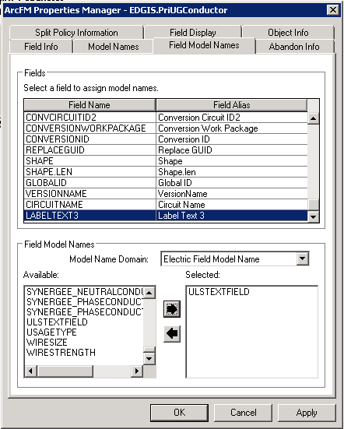

1. On the Field Info tab, select the LABELTEXT3 field
2. Modify the Visible property to No

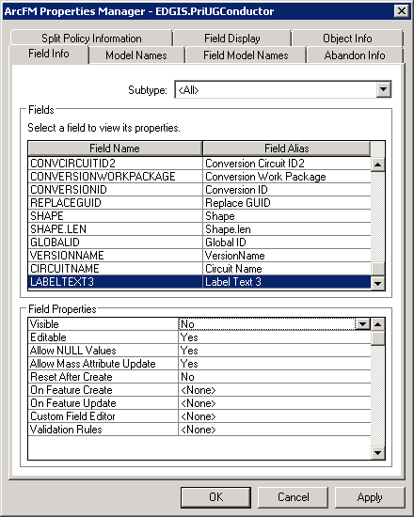

1. Right-click on the database node at the root level and select properties.
2. In the Domains tab, select the PGE ED Object Class Model Name domain.
3. Add a new entry for PGE_SECONDARYUGCONDUCTOR

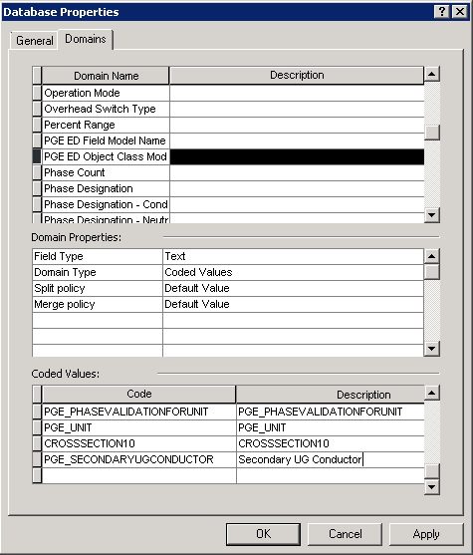

1. Add a new entry for PGE_DCCONDUCTOR

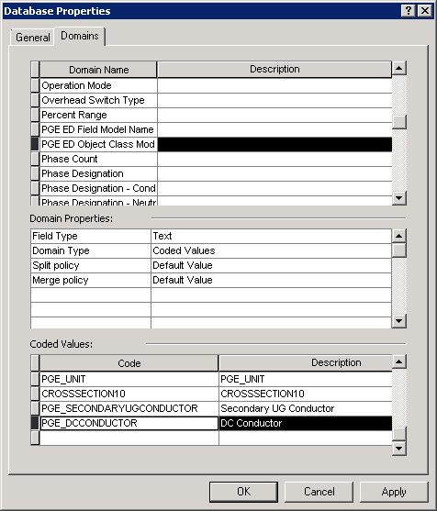

1. In the Domains tab, select the PGE ED Field Model Name domain.
2. Add a new entry for PGE_XSECTIONANNOCIRCUITID
3. Add a new entry for PGE_XSECTIONANNOCIRCUITID2

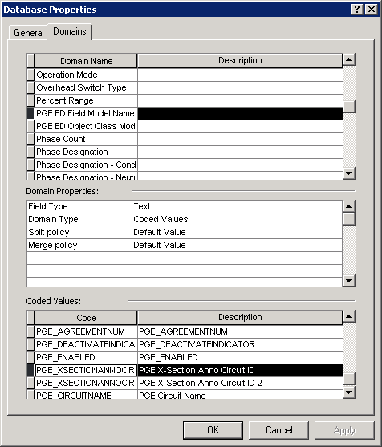

1. Right-click on the PriUGConductor feature class in the ElectricDataset dataset and select ArcFM Properties Manager.
2. On the Field Model Names tab, assign the PGE_XSECTIONANNOCIRCUITID field model name to the CONVCIRCUITID field.
3. On the Field Model Names tab, assign the PGE_XSECTIONANNOCIRCUITID2 field model name to the CONVCIRCUITID2 field.

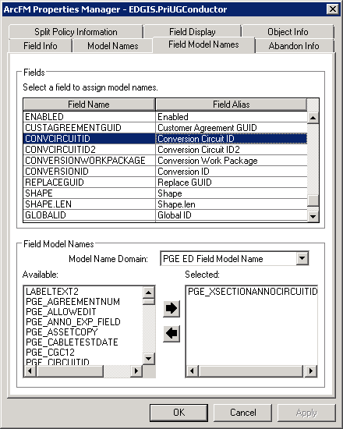

1. In the Object Info tab, pull down the On Feature Create event and select <Multiple…>
2. Add the PGE Cross Section Conductor Anno AU as the last AU in the list

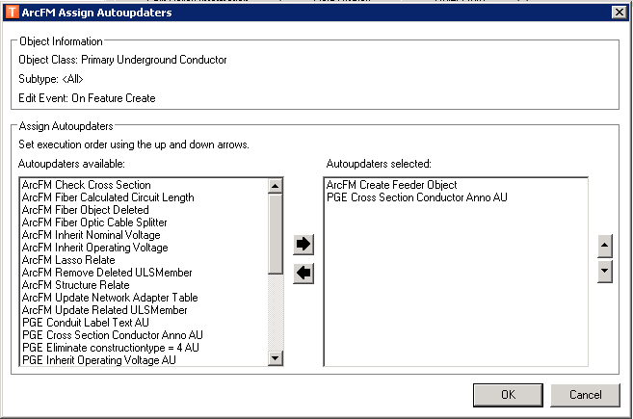

1. Pull down the On Feature Update event and select <Multiple…>
2. Add the PGE Cross Section Conductor Anno AU at the end of the list.

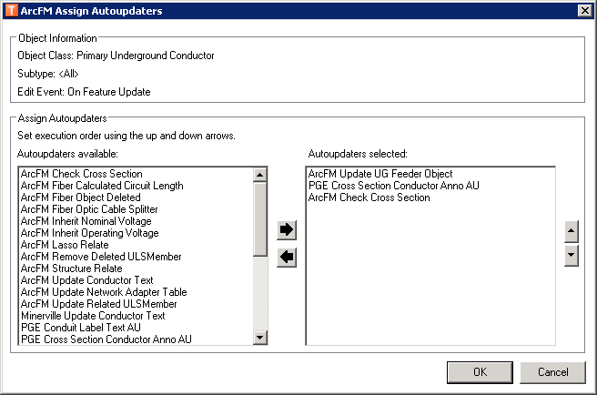

1. Right-click on the SecUGConductor feature class in the ElectricDataset dataset and select ArcFM Properties Manager.
2. On the Model Names tab, assign the PGE_SECONDARYUGCONDUCTOR model name.

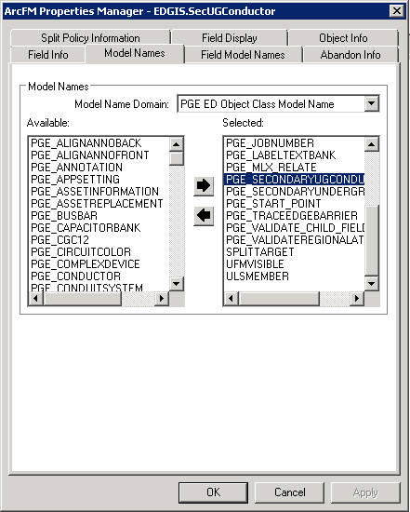

1. On the Field Model Names tab, assign the PGE_XSECTIONANNOCIRCUITID field model name to the CONVCIRCUITID field.
2. On the Field Model Names tab, assign the PGE_XSECTIONANNOCIRCUITID2 field model name to the CONVCIRCUITID2 field.

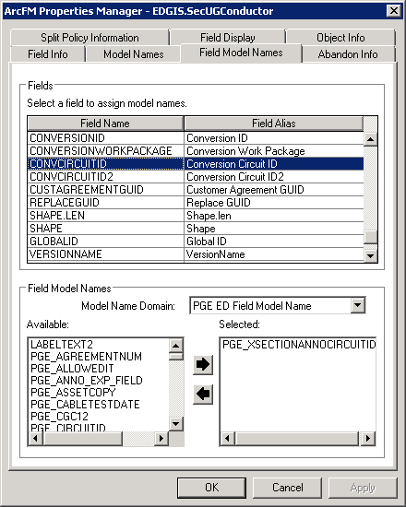

1. In the Object Info tab, pull down the On Feature Create event and select <Multiple…>
2. Add the PGE Cross Section Conductor Anno AU as the last AU in the list

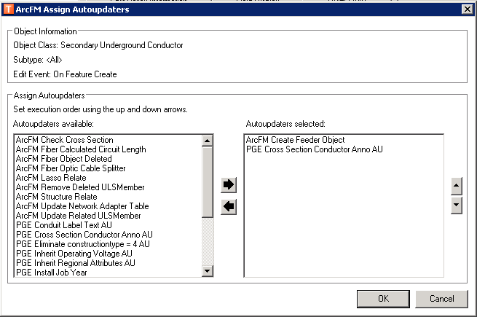

1. Pull down the On Feature Update event and select <Multiple…>
2. Add the PGE Cross Section Conductor Anno AU to just before the ArcFM Check Cross Section AU

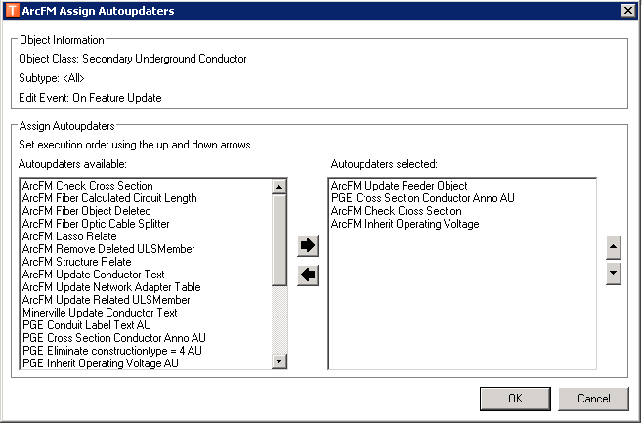

1. Right-click on the DCConductor feature class in the ElectricDataset dataset and select ArcFM Properties Manager.
2. On the Model Names tab, assign the PGE_DCCONDUCTOR model name.

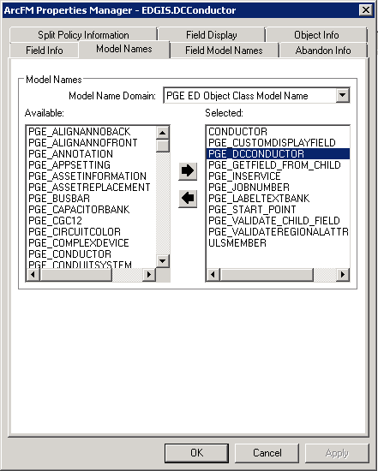

1. On the Field Model Names tab, assign the PGE_XSECTIONANNOCIRCUITID field model name to the CONVCIRCUITID field.
2. On the Field Model Names tab, assign the PGE_XSECTIONANNOCIRCUITID2 field model name to the CONVCIRCUITID2 field.

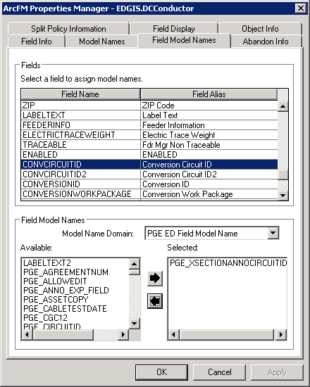

1. In the Object Info tab, pull down the On Feature Create event and select <Multiple…>
2. Add the PGE Cross Section Conductor Anno AU as the last AU in the list

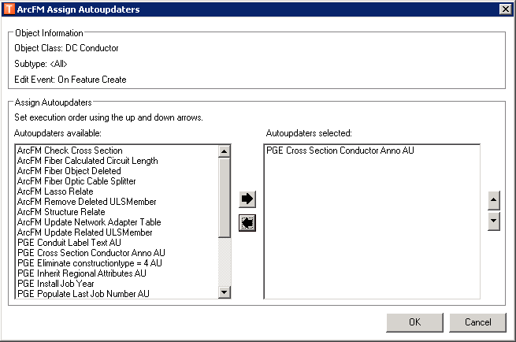

1. Pull down the On Feature Update event and select <Multiple…>
2. Add the PGE Cross Section Conductor Anno AU to just before the ArcFM Check Cross Section AU

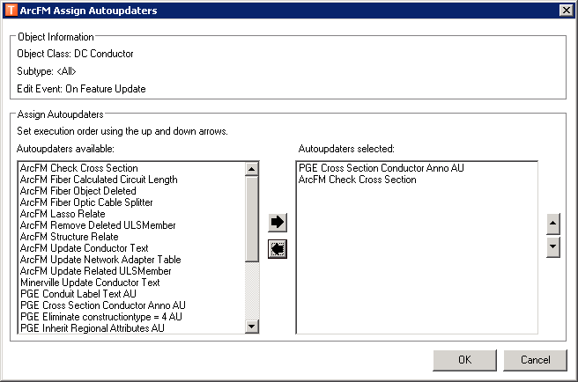

# Dupe attributes that drive symbology for data entry

1. Right click the database and select Properties.

2. In the Domains tab, scroll to the bottom and add the following new domain:

Name:Duct Shape

Alias: Duct Shapes

Field Type: Text

Domain Type: Coded values

Split: Default value

Merge: Default value

Coded Values:  
CI/Circle

SQ/Square

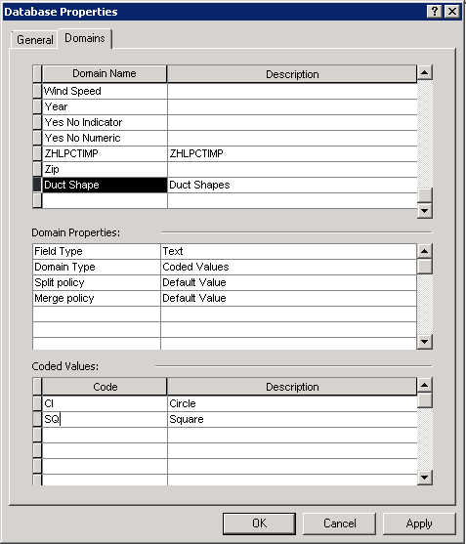

3. Click OK.

4. In the UFMDataset, double click Duct.

5. In the Fields tab, click the DUCTSHAPE field and assign the Duct Shape domain to the field.

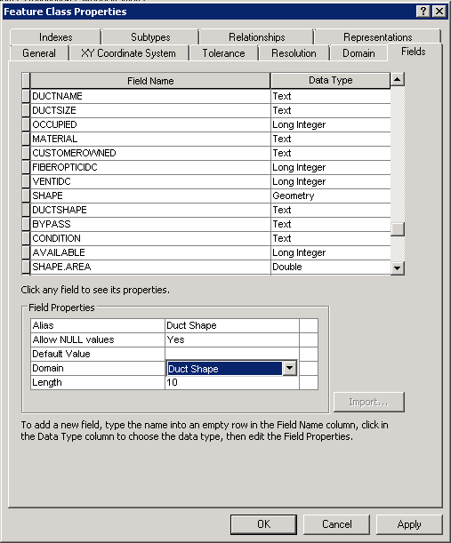

# Create new fields in DuctDefinition object class

1. In the root level, double click DuctDefinition.

2. In the Fields tab, scroll to the bottom of the list.

3. Add the following fields:

Create DUCTSHAPE field on the DuctDefinition object class   
Alias: Duct Shape  
Data Type: Text  
Allow Null: Yes  
Domain: Duct Shape  
Length: 10

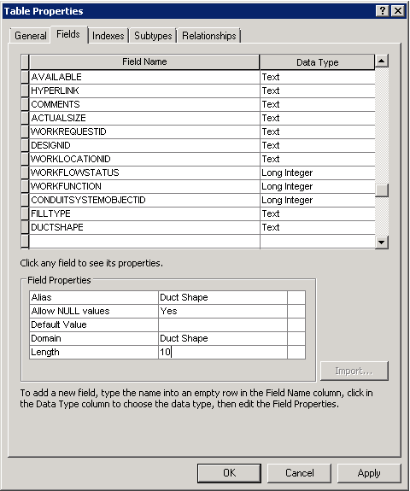

Create BYPASS field on the DuctDefinition object class   
Alias: Bypass  
Data Type: Text  
Allow Null: Yes  
Domain: Yes No Indicator  
Length: 10

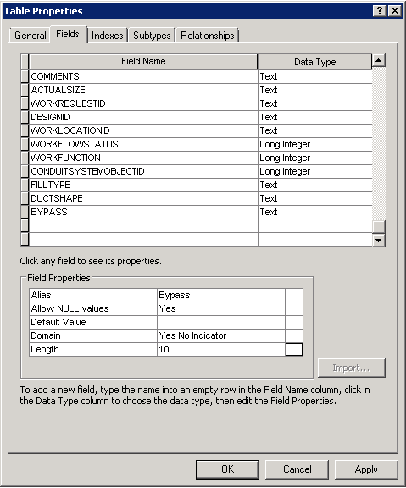

Create CONDITION field on the DuctDefinition object class  
Alias: Condition  
Data Type: Text  
Allow Null: Yes  
Domain: Duct Use Condition  
Length: 10

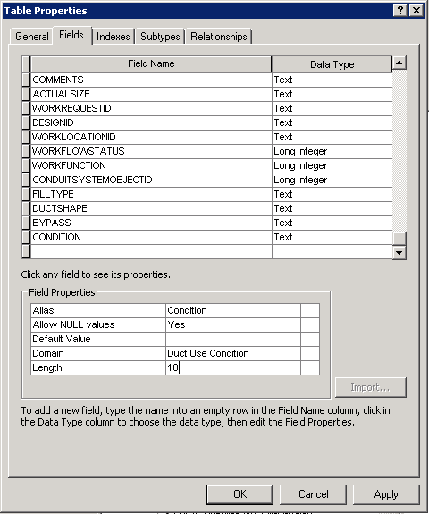

Create FIBEROPTICIDC field on Duct Definition object  
Alias: Fiber Optic Indicator  
Data Type: Long Integer  
Allow Null: Yes  
Default Value: 0  
Domain: Yes No Numeric  
Precision: 10

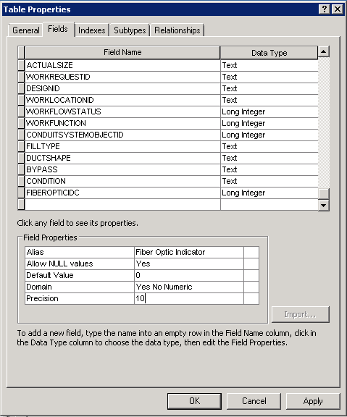

Create VENTIDC field on the DuctDefinition object class  
Alias: Vent Indicator  
Data Type: Long Integer  
Allow Null: Yes  
Domain: Yes No Numeric  
Precision: 10

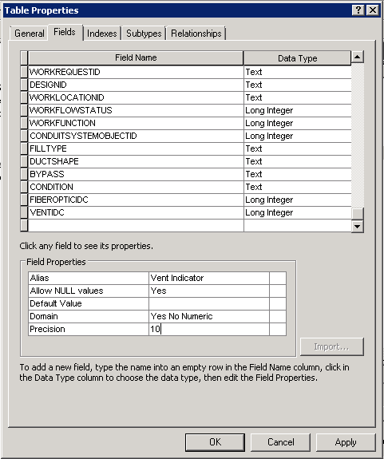

# Create new fields in DuctBank feature class

1. In the UFMDataset, double click DuctBank.

2. In the Fields tab, scroll to the bottom of the list.

3. Add the following fields:

Create NOTE1 text field on the DuctBank feature class  
Alias: Duct Bank Note 1  
Data Type: Text  
Allow Null: Yes  
Length: 255

Create NOTE2 text field on the DuctBank feature class  
Alias: Duct Bank Note 2  
Data Type: Text  
Allow Null: Yes  
Length: 255

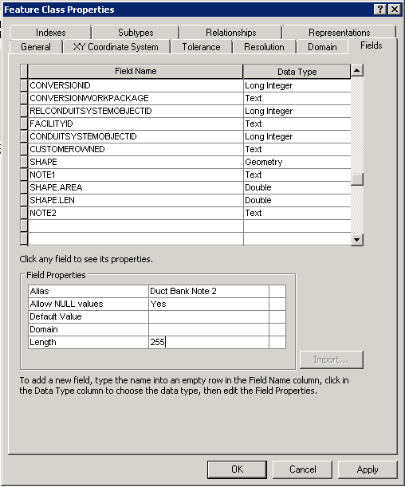

# Create new fields in SubsurfaceStructure feature class

1. In the ElectricDataset, double click SubsurfaceStructure.

2. In the Fields tab, scroll to the bottom of the list.

3. Add the following fields:

Create NOTE1 text field

Alias: Vault Note 1

Data Type: Text  
Allow Null: Yes  
Length: 255

Create NOTE2 text field  
Alias: Vault Note 2  
Data Type: Text  
Allow Null: Yes  
Length: 255

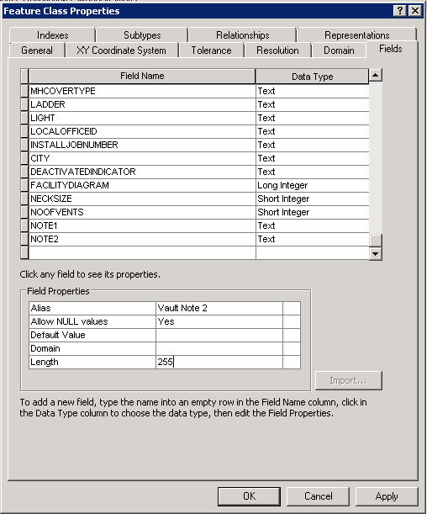

# Create new fields in Duct feature class

1. In the UFMDataset, double click Duct.

2. In the Fields tab, scroll to the bottom of the list.

3. Add the following fields:

Add FILLTYPE field on the Duct feature class   
Alias: Fill Type  
Data Type: Text  
Allow Null: Yes  
Default: ED  
Domain: Fill Type  
Length: 5

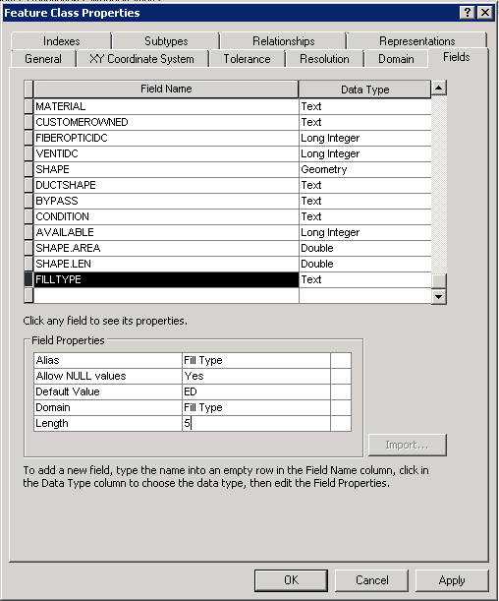

# Add LabelText 2 field to SecUGConductor

1. In the ElectricDataset, double click SecUGConductor.

2. In the Fields tab, scroll to the bottom of the list.

3. Add the following field:

Add LABELTEXT2 field

Alias: Label Text 2

Data Type: Text  
Allow Null: Yes  
Length: 100

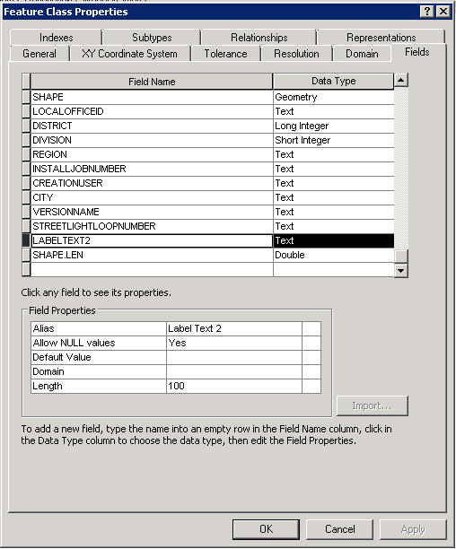

4. Click OK.

5. Right click SecUGConductor and select ArcFM Properties Manager.

6. In the Field Model Names tab, select LABELTEXT.

7. Double click ULSTEXTFIELD from the 'Selected' box to unassign the model name.

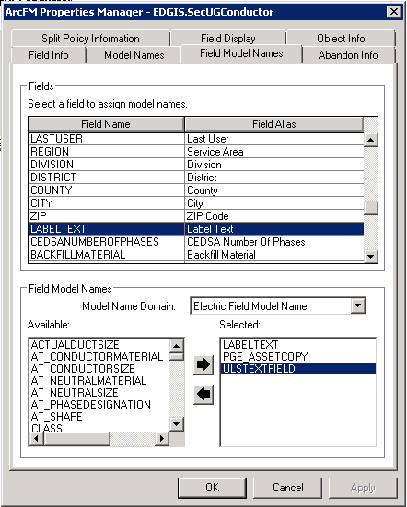

8. Select the LABELTEXT2 field.

9. In the 'Available' box, double click the ULSTEXTFIELD to assign the model name to the field.

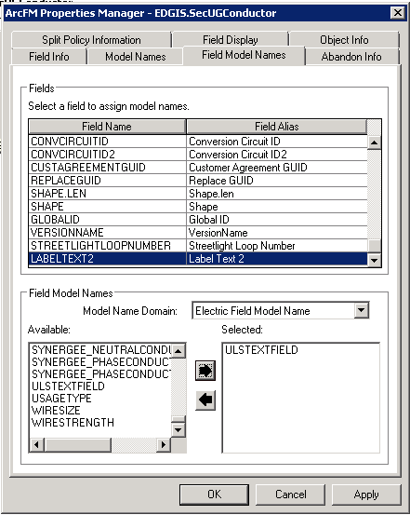

1. On the Field Info tab, select the LABELTEXT2 field
2. Modify the Visible property to No

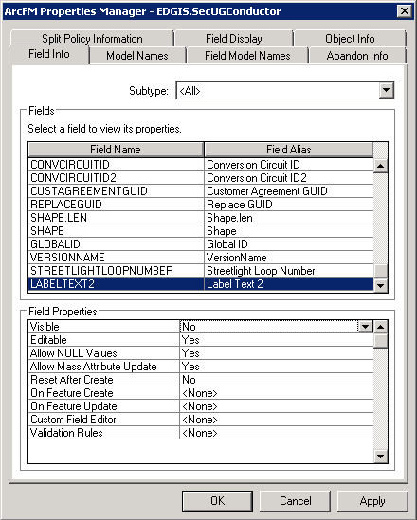

# Add LabelText 2 field to DCConductor

1. In the ElectricDataset, double click DCConductor.

2. In the Fields tab, scroll to the bottom of the list.

3. Add the following field:

Add LABELTEXT2 field

Alias: Label Text 2

Data Type: Text  
Allow Null: Yes  
Length: 100

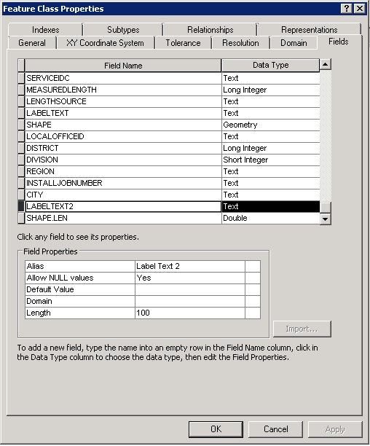

4. Click OK.

5. Right click DCConductor and select ArcFM Properties Manager.

6. In the Field Model Names tab, select the LABELTEXT2 field.

7. In the 'Available' box, double click the ULSTEXTFIELD to assign the model name to the field.

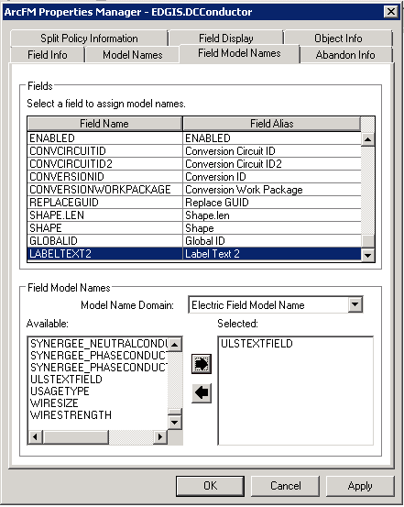

8. Select the LABELTEXT field.

9. In the 'Available' box, double click the LABELTEXT to assign the model name to the field. Note the LABELTEXT field model name is in the independent field model name domain.

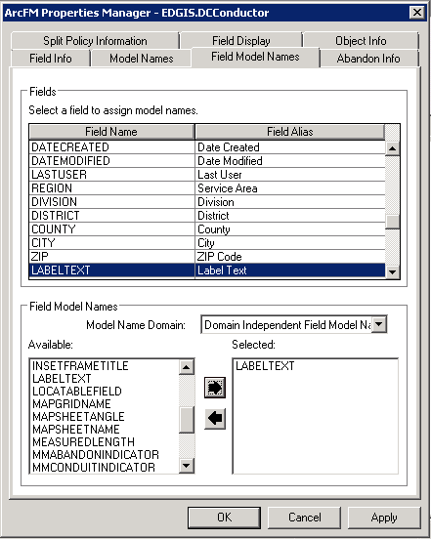

1. On the Field Info tab, select the LABELTEXT2 field
2. Modify the Visible property to No

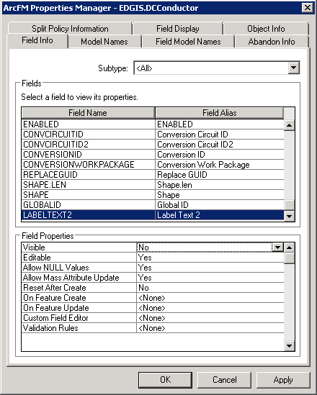

# DCConductor Labelling

1. In the ElectricDataset dataset, right click DCConductor and select ArcFM Properties Manager.

2. In the Model Names tab, add the PGE_LABELTEXTBANK model name.

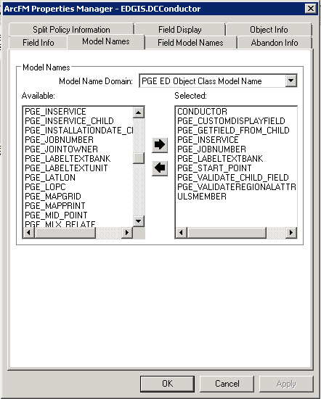

3. In the root node of database, right click DCConductorInfo and select ArcFM Properties Manager.

4. In the Model Names tab, add the PGE_LABELTEXTUNIT model name.

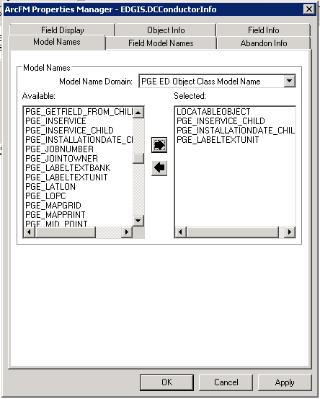

1. Select OK and in the Electric Dataset, right click the DCConductor feature class and select ArcFM Properties Manager.
2. In the Object Info tab, select the On Feature Create event and click <Multiple…>
3. Assign the PGE DCConductor LabelText AU at the end of the list

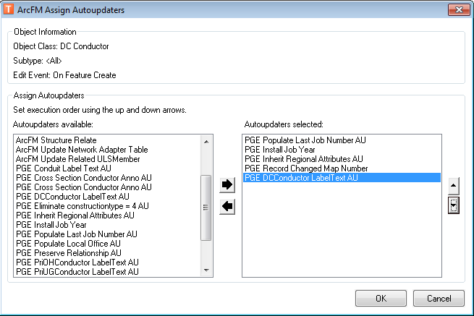

1. In the Object Info tab, select the On Feature Update event and click <Multiple…>
2. Assign the PGE DCConductor LabelText AU at the end but before the ArcFM Check Cross Section AU if present

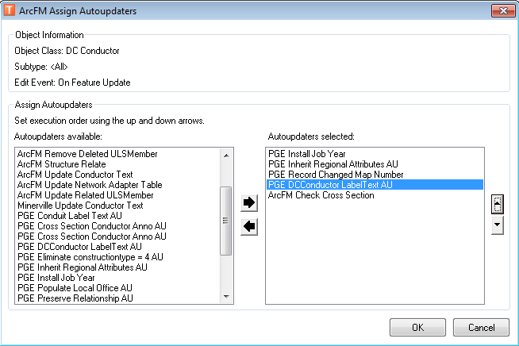

# Modify PGE_CIRCUITCOLOR table

1. In the root folder, double click PGE_CIRCUITCOLOR.
2. In the Fields tab, add a new field as follows:
   1. Name: CIRCUITNAME
   2. Data Type: Text
   3. Alias: Circuit Name
   4. Allow Null: Yes
   5. Length: 50

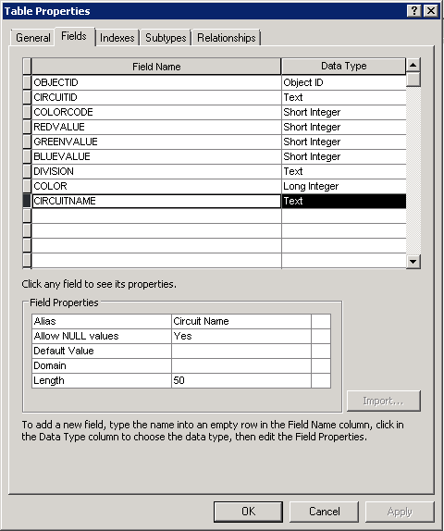

1. Right-click on the database node at the root level and select properties.
2. In the Domains tab, select the PGE ED Field Model Name domain.
3. Add a new entry for PGE_CIRCUITNAME.

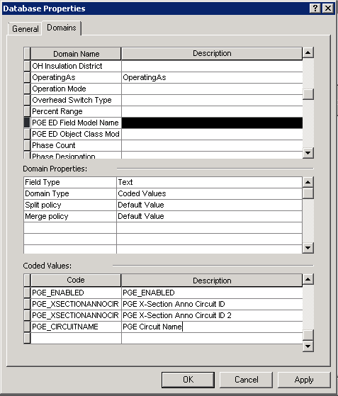

1. At the root level, right-click on the PGE_CIRCUITCOLOR table and select ArcFM Properties Manager.
2. On the Field Model Names tab, add the PGE_CIRCUITNAME field model name to the new Circuit Name field of the PGE_CIRCUITCOLOR table

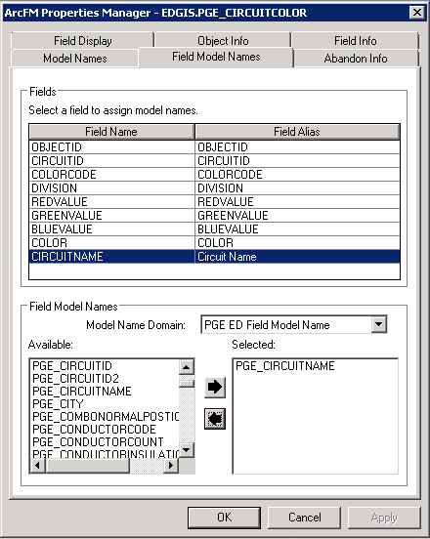

# Create Missing Relationship Between DCConductor and Duct

1. At the root level, right click in the empty area in the Contents tab of the right side panel.
2. Select New->Relationship Class

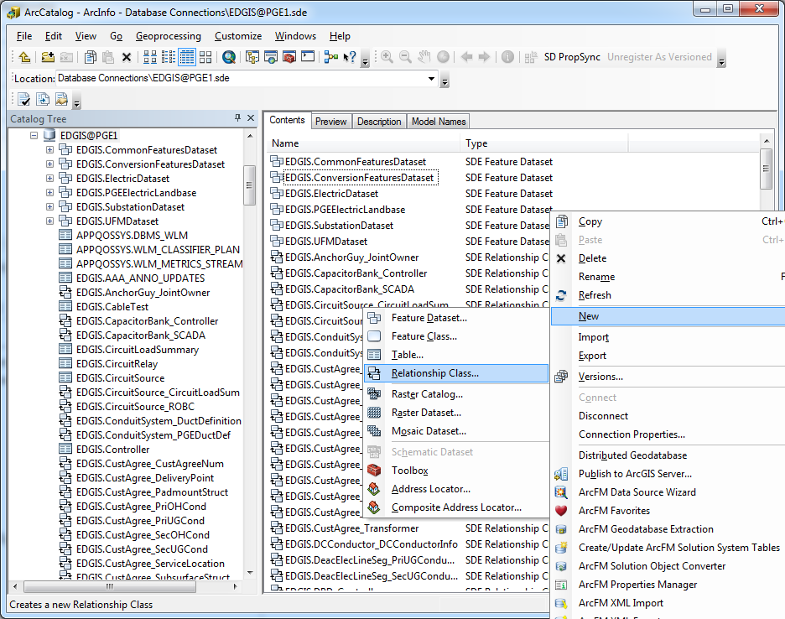

1. Set the properties of the relationship class according to the following screens:

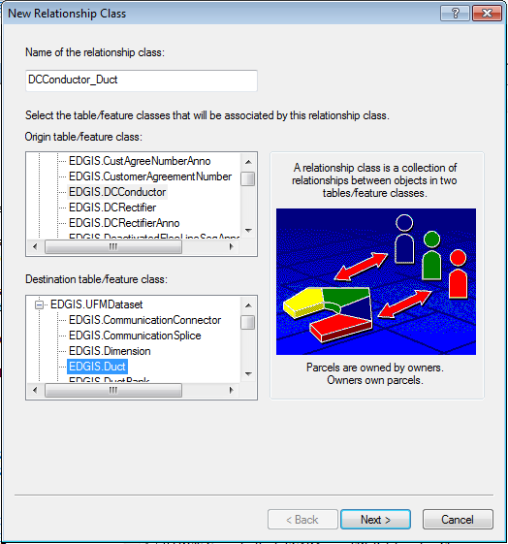

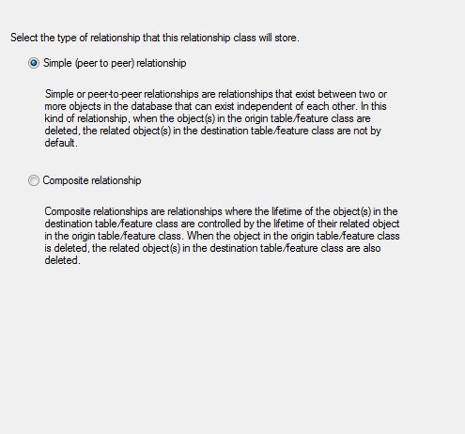

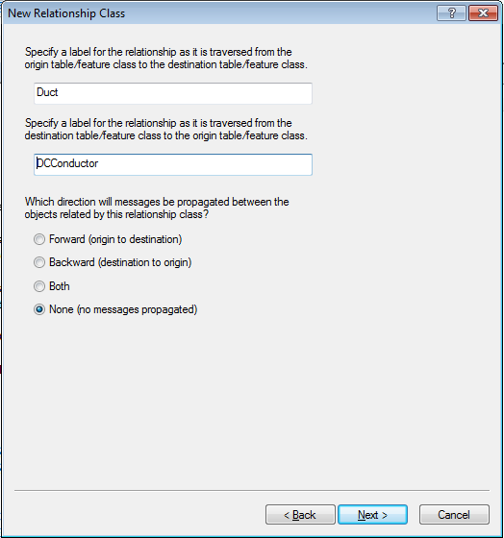

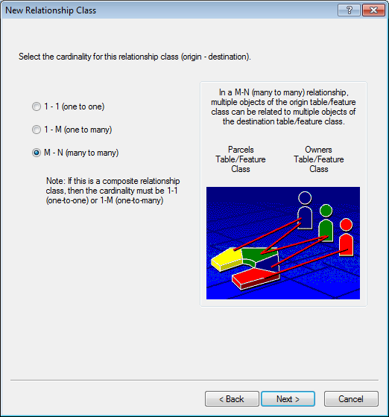

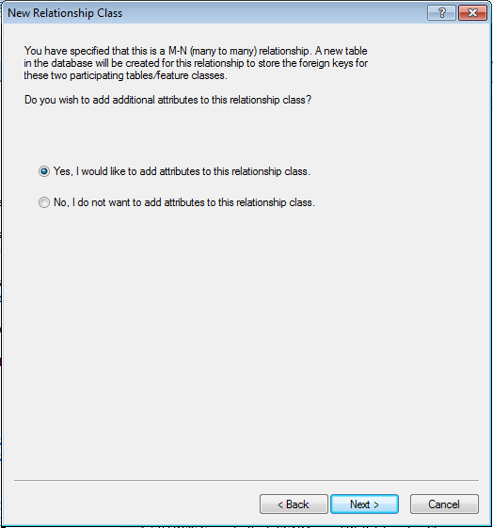

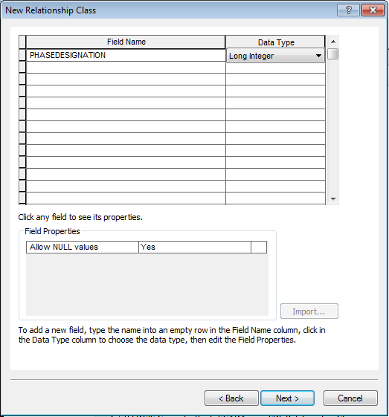

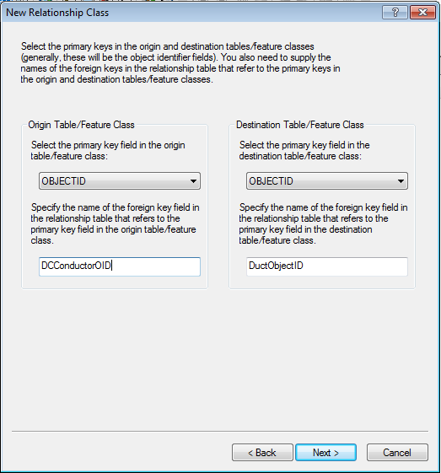

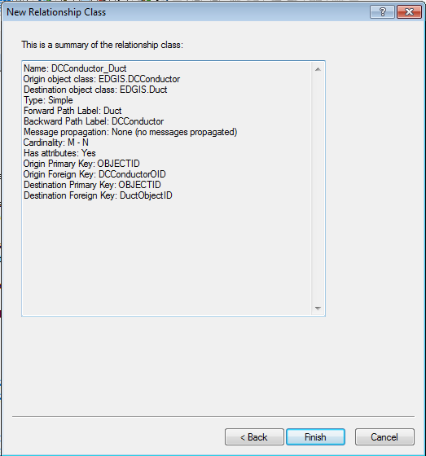

1. Add GlobalID by right clicking the DCConductor_Duct relationship class and clicking “Add Global IDs…”
2. Click “Yes”

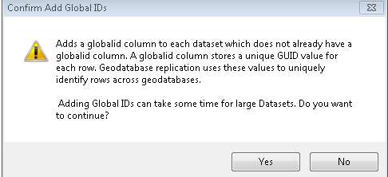

1. Observe GLOBALID has been added to the relationship class.

# Apply Missing UFM Autoupdaters

1. In the ElectricDataset, right click ConduitSystem and select ArcFM Properties Manager.
2. On the Object Info tab, select the On Feature Update property and select ‘<Multiple…>’
3. Add the ArcFM Check Cross Section AU to the list at the bottom.

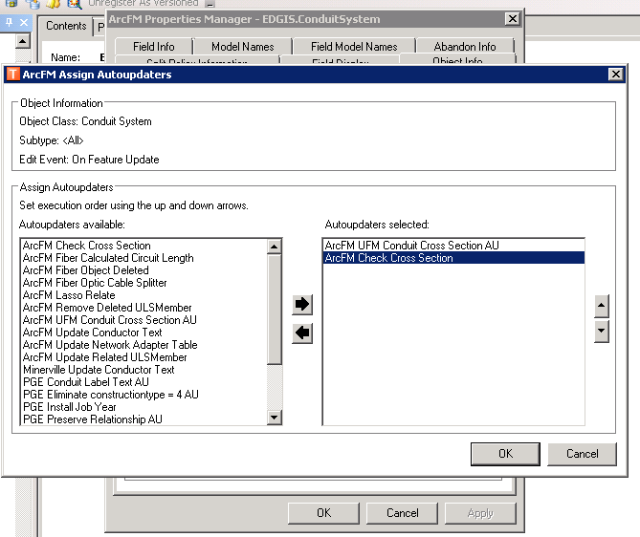

1. Right click PriUgConductor and select ArcFM Properties Manager.
2. On the Object Info tab, select the On Feature Update property and select ‘<Multiple…>’
3. Add the ArcFM Check Cross Section AU to the list at the bottom.

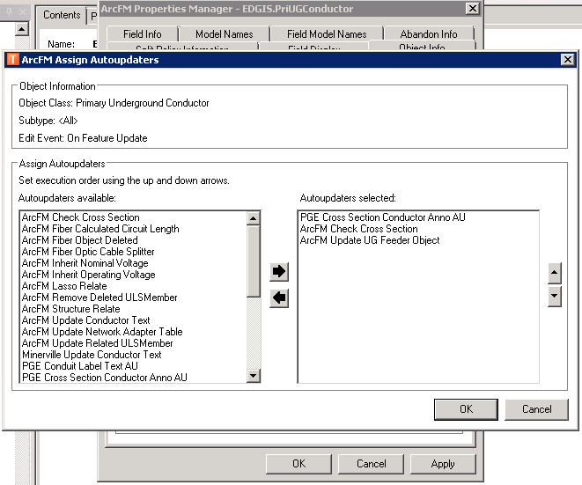

1. Right click the ConduitSystem_DCConductor relationship and select ArcFM Properties Manager.
2. Assign the ArcFM Conduit to Conductor Composite AU to each of the create, update and delete events.

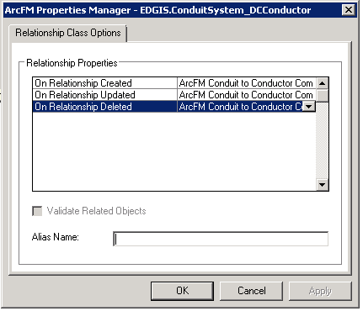

1. Right click the PriUGConductor_Duct relationship in the root level and select ArcFM Properties Manager.
2. Assign the ArcFM UFM Duct to Conductor Relationship AU to each of the create, update and delete events.

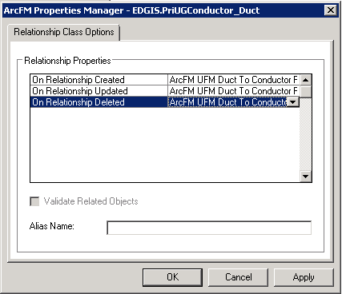

1. Right click the SecUGConductor_Duct relationship in the root level and select ArcFM Properties Manager.
2. Assign the ArcFM UFM Duct to Conductor Relationship AU to each of the create, update and delete events.

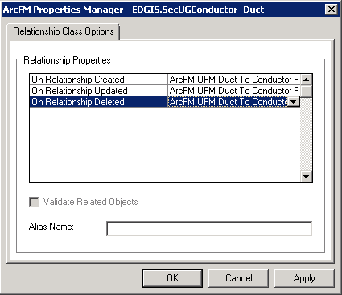

1. Right click the DCConductor_Duct relationship and select ArcFM Properties Manager.
2. Assign the ArcFM UFM Duct to Conductor Relationship AU to each of the create, update and delete events.

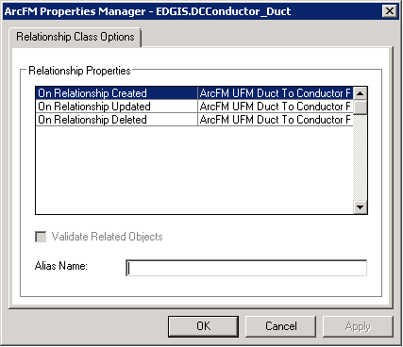

# Add Butterfly Cross Section feature class

1. Right-click on the ElectricDataset and select New->Feature Class
2. Follow the following screens to create the annotation class

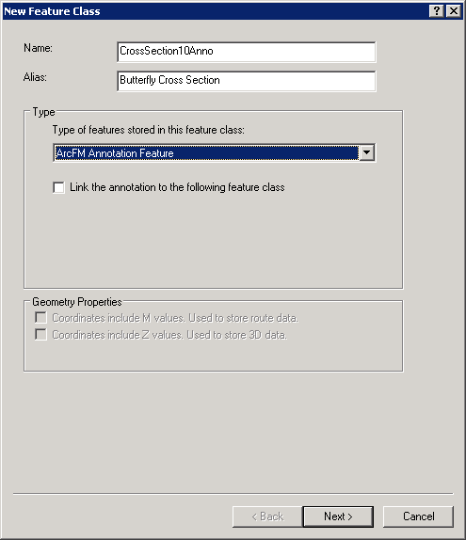

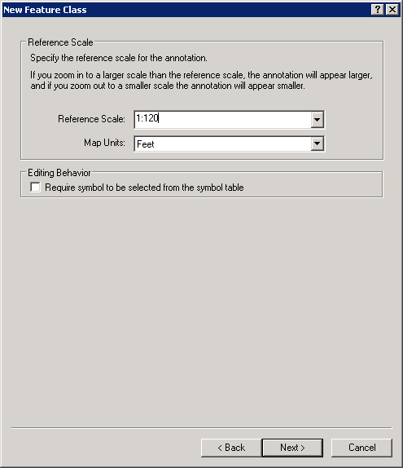

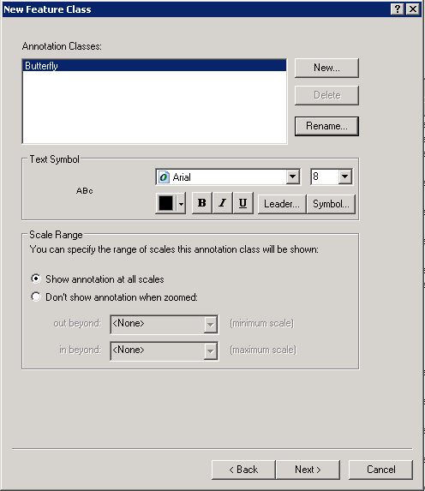

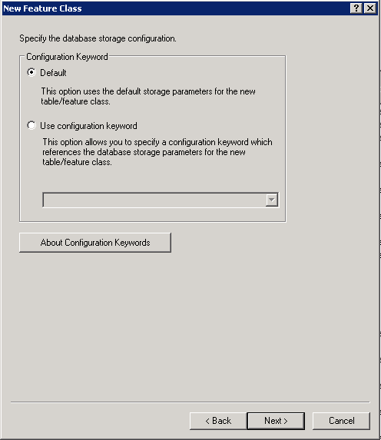

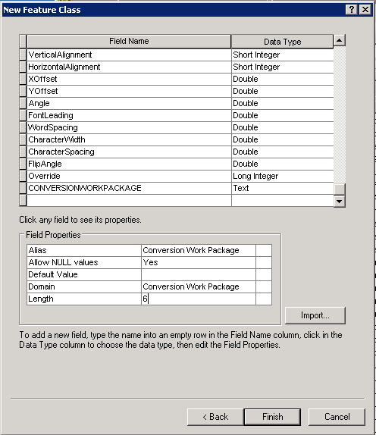

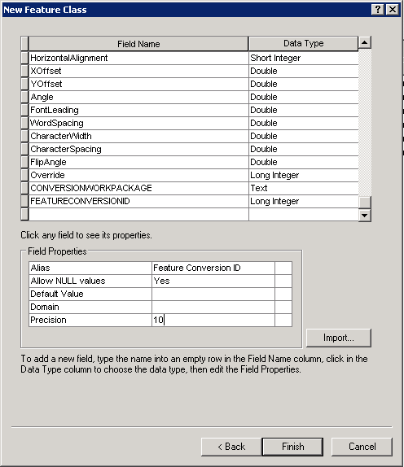

1. Right-click on the ElectricDataset and select New->Relationship Class
2. Follow the following screens to create the annotation class

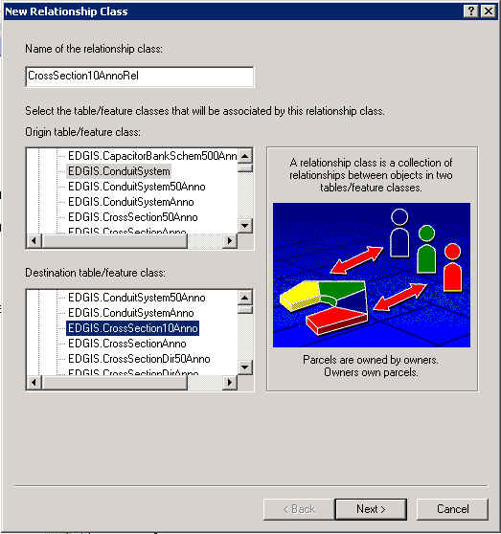

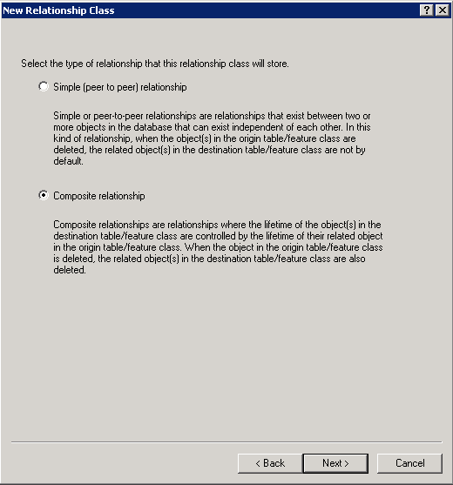

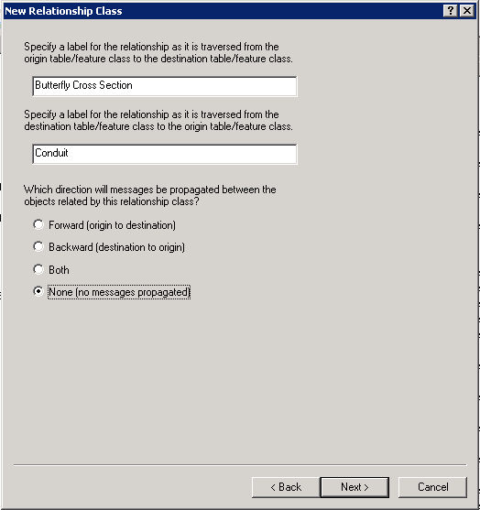

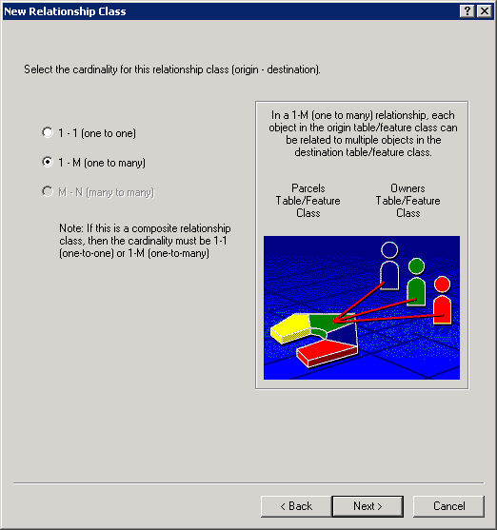

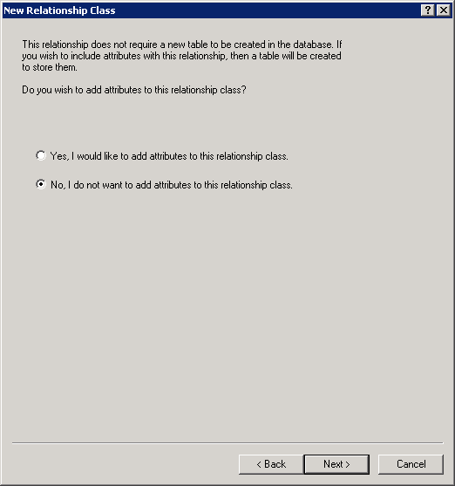

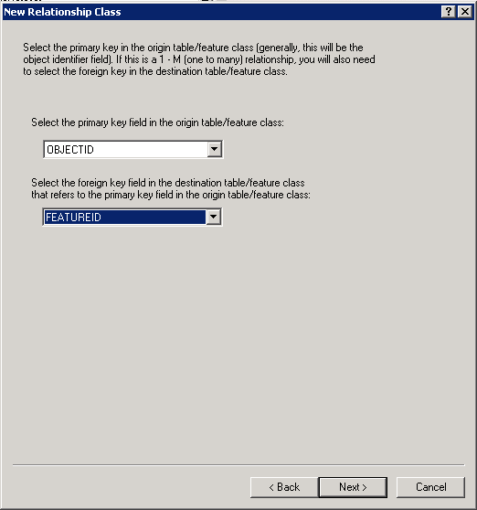

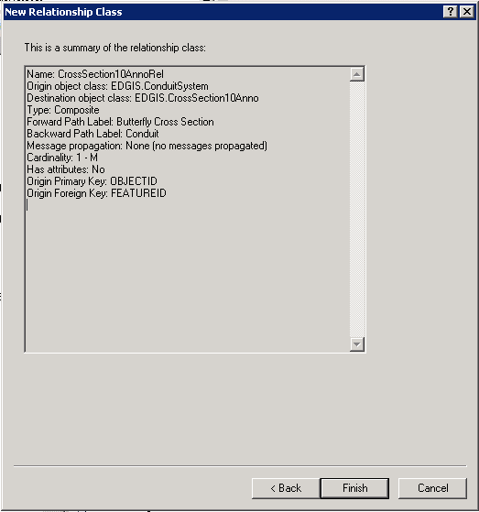

1. Add GlobalID by right clicking the EDGIS.ElectricDataset and clicking “Add Global IDs…”
2. Click “Yes”



1. Observe GLOBALID has been added to the CrossSection10Anno feature class.
2. Right-click on the database node at the root level and select properties.
3. In the Domains tab, select the PGE ED Object Class Model Name domain.
4. Add a new entry for CROSSSECTION10.
5. Right-click on the CrossSection10Anno feature class in the Electric dataset and click ArcFM Properties Manager.
6. On the Model Names tab, assign the CROSSSECTION10 model name.
7. Also assign the UFMVISIBLE model name

# Add Conversion Fields to the 1:50 Cross Section Anno

1. In the ElectricDataset, double click on the CrossSection50Anno Feature Class
2. Select the Fields tab
3. Add a ConversionWorkPackage field

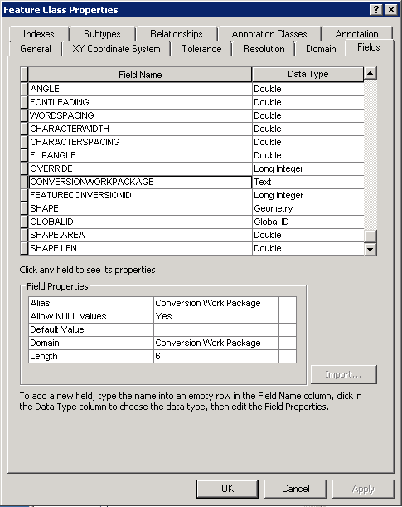

1. Add a FeatureConversionId field

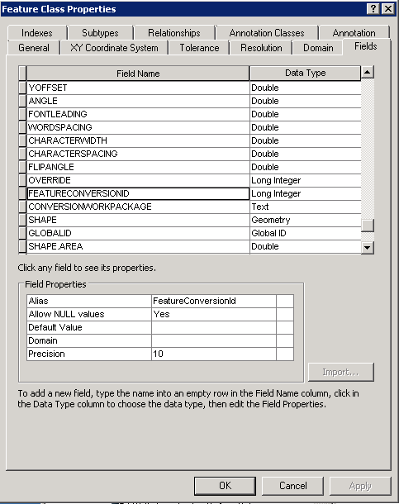

# Add Annotation Feature Class for VaultPoly

1. In the Electric Dataset, right-click on the VaultPoly feature class and select Properties
2. Add a new field

Name: STRUCTURENUMBER

Alias: Structure Number

Type: Text

Length: 12

Allow Null: Yes

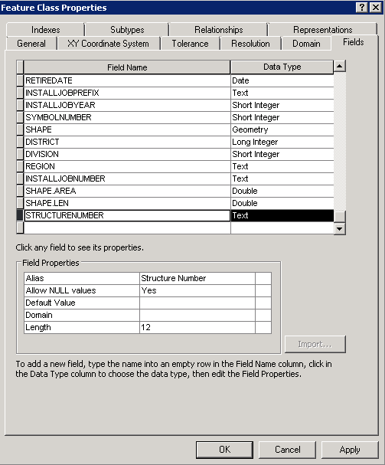

1. Click OK
2. Right-click on the Electric Dataset and select New->Feature Class
3. Select ArcFM Annotation Feature and link to the VaultPoly FC

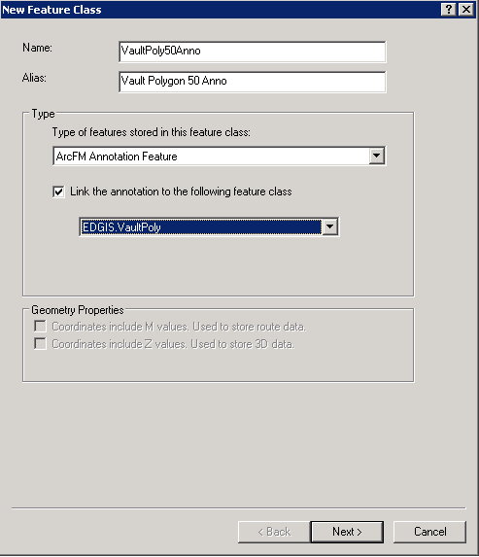

1. Specify a reference scale of 1:600

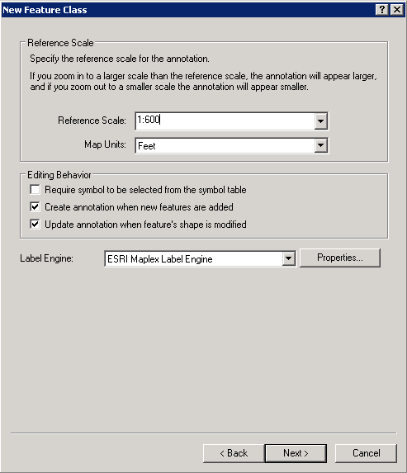

1. Specify StructureNumber as the annotation class name and the expression as StructureNumber and set the font size to 6.

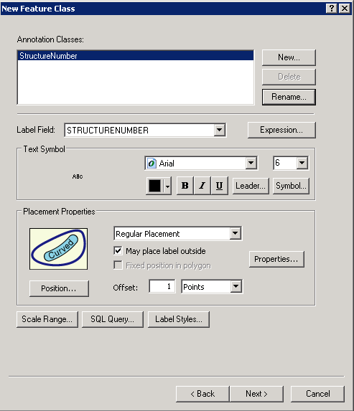

1. Add a CONVERSIONWORKPACKAGE Field.



1. Add a FEATURECONVERSIONID field.



1. Click Finish

# Apply Permissions to new Classes

1. Right click the ElectricDataset and select Privileges
2. Type in a role (from the below list), type 'grant' for the corresponding permissions, and click OK.
3. Repeat steps 1 and 2 for all roles.

SDE_EDITOR - View/edit

SDE_VIEWER - View

DAT_EDITOR - View

DATACONV - View

GIS_INTERFACE – View

GISINTERFACE - View

1. Right click the ElectricDataset and select Privileges.
2. Remove the ElectricDataset from the Input Dataset list.
3. Add the DCConductor_Duct relationship class from the root folder.

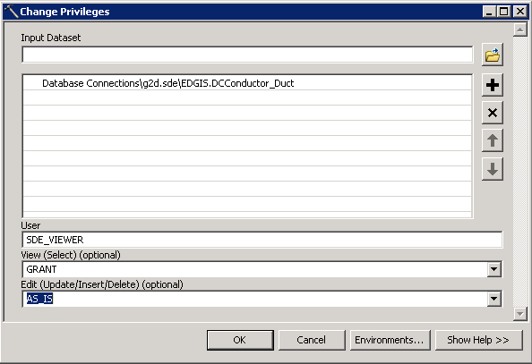

1. Type in a role (from the below list), type 'grant' for the corresponding permissions, and click OK.
2. Repeat steps 4, 5, 6 and 7 for all roles.

SDE_EDITOR - View/edit

SDE_VIEWER - View

DAT_EDITOR - View

DATACONV - View

GIS_INTERFACE – View

GISINTERFACE - View

# Apply UFM Annotation Model Names

1. Right-click on the database node and select Properties
2. On the domain tab, select the Electric Object Class Model Name domain
3. Add a new entry for UFMANNOTATION and click OK

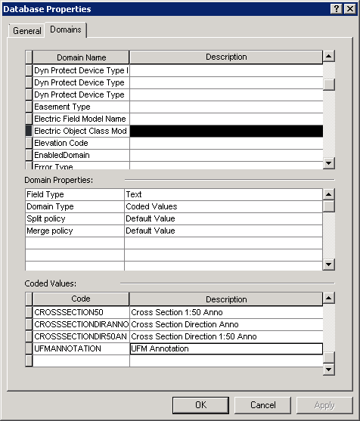

1. In the UFM Dataset, right click on DuctAnnotation and select ArcFM Properties Manager.
2. In the Model Names tab, remove the UFMANNO model name
3. Assign the UFMANNOTATION model name

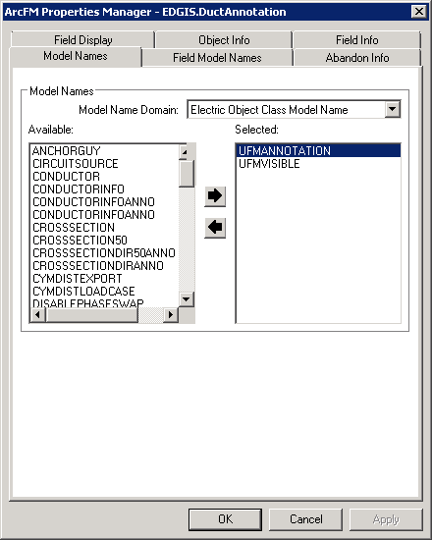

1. In the UFM Dataset, right click on DuctNoteAnno
2. In the Model Names tab, remove the UFMANNO model name
3. Assign the UFMANNOTATION model name

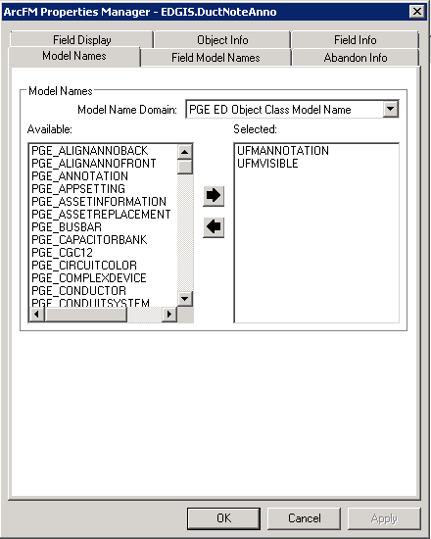

# Update Duct Annotation

1. Expand the UFM Dataset, right-click on the DuctAnnotation feature class and select Properties.
2. Select the Annotation Classes tab
3. Select the ‘Position’ button
4. Select ‘Horizontal’

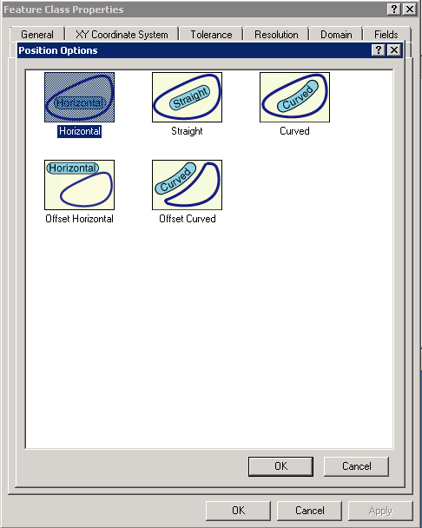

1. Click OK

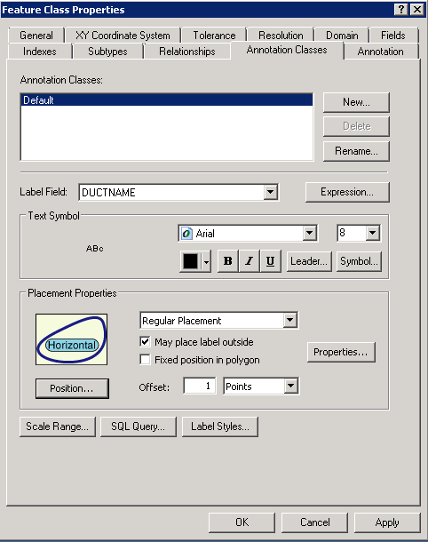

1. Click OK

# Update Map Mulitplier

1. At the database level, right-click and select “ArcFM Properties Manager”.
2. In the Underground Facilities tab, modify the Map Size Miltipler from 18 to 16.

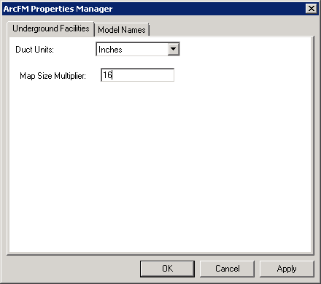

# Update Data Model Version Table

**Database Configuration:**

1. Open SQL Plus.
2. Log in using the same server and user as was used in section 2.  
     
   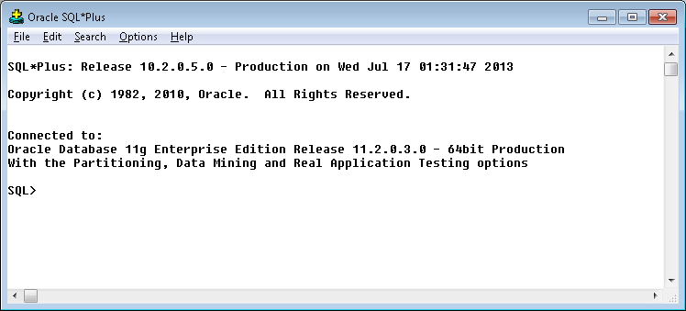
3. Run the SQL below:

update pgedatamodelversion set currentidc='N' where currentidc='Y';

insert into pgedatamodelversion (OBJECTID, CURRENTIDC, DATEAPPLIED, APPLIEDBYPERSONNAME, MODELVERSION) values (**INSERT NEXT VALID ID**,'N',sysdate,'**<INSERT TEAM MEMBER DONE BY>**','**8.4** GOLD **PLACEHOLDER (7.x+8.3)**');

insert into pgedatamodelversion (OBJECTID, CURRENTIDC, DATEAPPLIED, APPLIEDBYPERSONNAME, MODELVERSION) values (**INSERT NEXT VALID ID**,'Y',sysdate,'**<INSERT TEAM MEMBER DONE BY>**','**8.5** GOLD **CR<INSERT CR NUMBER>**');

commit;

# Known Issues

<Please List any other issues encountered here while following the document>